REPORT OF ACTIVITIES

Department | MBA (AFMR)
Name of Event | Yavnika Hobby Club Talent Hunt 2025
Date of Event | 24th September, 2025
Venue | Smt. Kamal Prabha Auditorium
Objective of Event | To provide a creative platform for students to showcase  their talent while also encouraging relaxation, joy and  stress relief through dance and music
Judges | Dr. Pushpa Pathak (FCA, AITR), Dr. Sushma Patidar (AITR)
Coordinator | Dr. Shweta Choudhary (Coordinator Marketing Club)
Details of Participants | Around 430 students MBA I Sem batch 2025-27
Results- | Dance-  1) Sanskar Kaushal  2) Muskan Yaddav  Singing-  1) Kumkum Yadav  2) Saksham Garg

Highlights-

Yavnika Hobby club organized its activity on 24th September 2025 in Smt. Kamal Prabha auditorium from 12.30 to 2.30 pm for MBA I sem. students (Batch 2025-27). The club conducted dance and singing competition seeking participation from the students of new batch. There were more than 100 nominations for the competition which were properly screened and 16 final contestants were given the opportunity to perform over the stage. The competition commenced with the lamp lighting ceremony, followed by the floral welcome of the distinguished judges Dr. Pushpa Pathak and Dr. Sushma Patidar respectively by Dr. Rajeshwari Gwal and Dr. Sarita Rana. The presence of the faculty members of AFMR helped in ensuring decorum of the program. The event was well conducted with the help of volunteers of Yavnika Hobby Club and Discipline committee from MBA III Sem. The participants gave mesmerizing performances living lasting impression over the audience. During the decisive moments of the judges evaluation, YHC volunteers engaged the audience with fun quizzes awarding chocolates for right answers. The students enjoyed and got the learning that was deliberated through the event. The winning participants were acknowledged with prizes which boosted enthusiasm amongst all. Memento was given to our esteemed guests by Dr. Sandeep Singh and Dr. Payal Sharma. The event was concluded with vote of thanks by Dr. Shweta Choudhary.
Prepared By: Dr. Shweta Choudhary (Yavnika Hobby Club Coordinator)

Snapshots of fun memories-

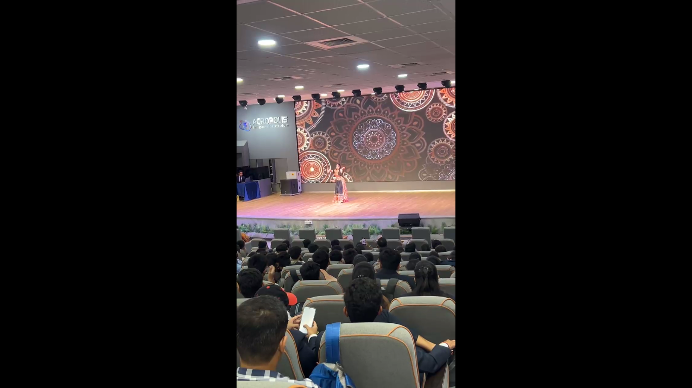 | 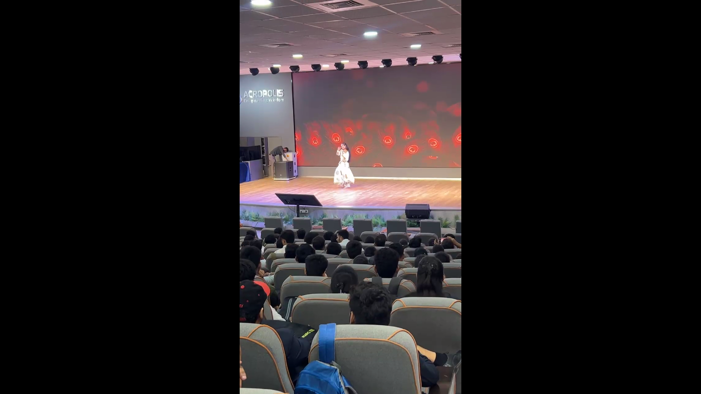
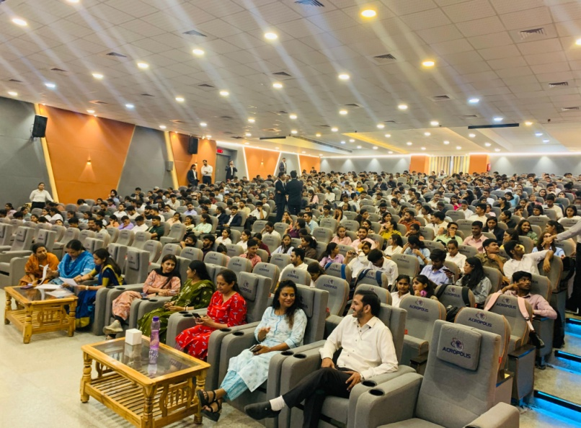 | 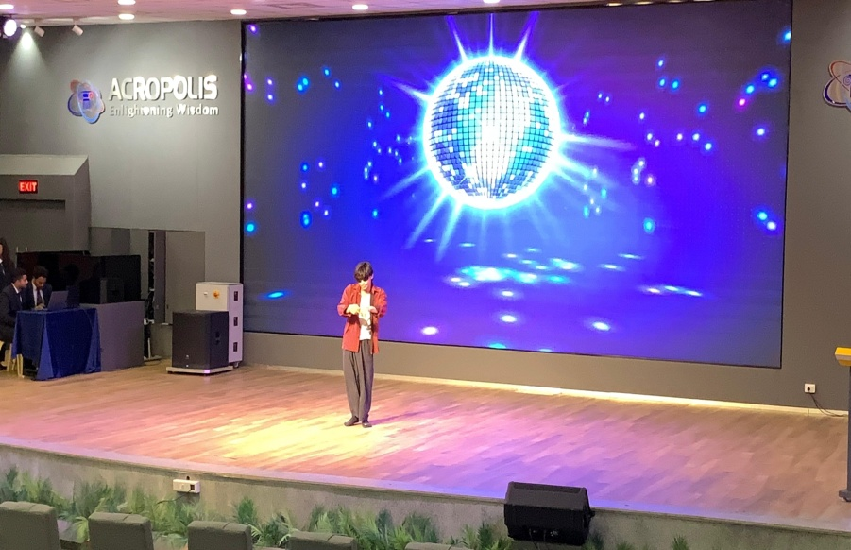
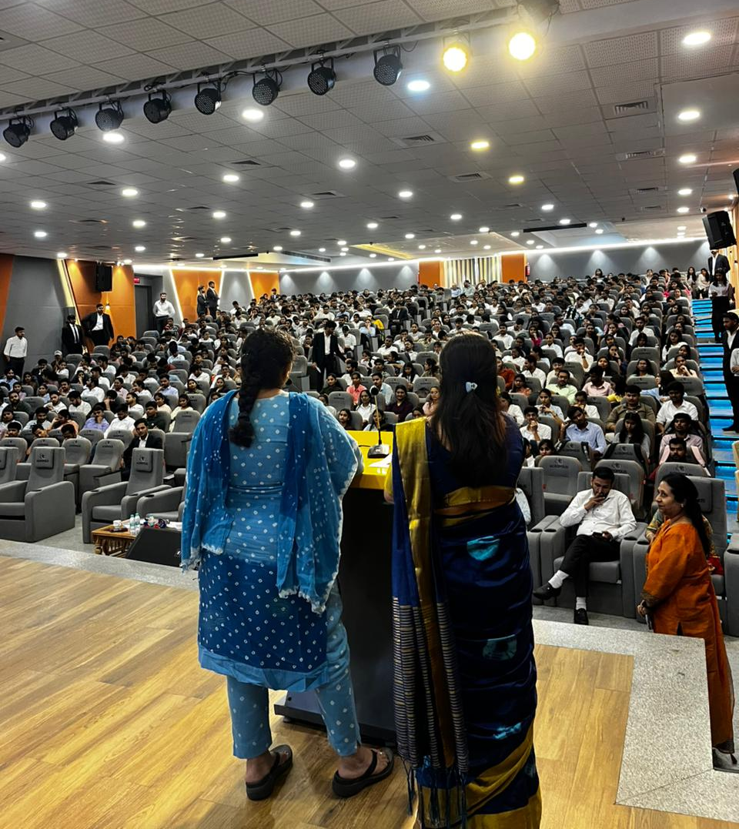 | 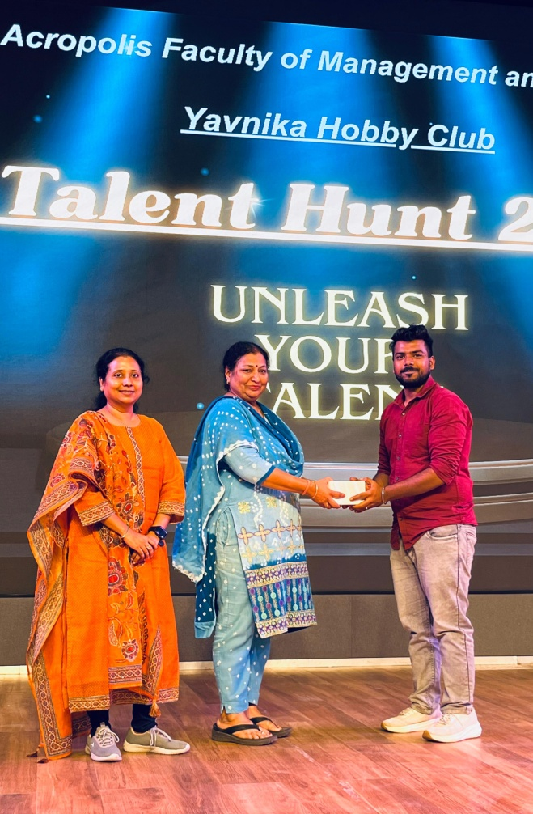
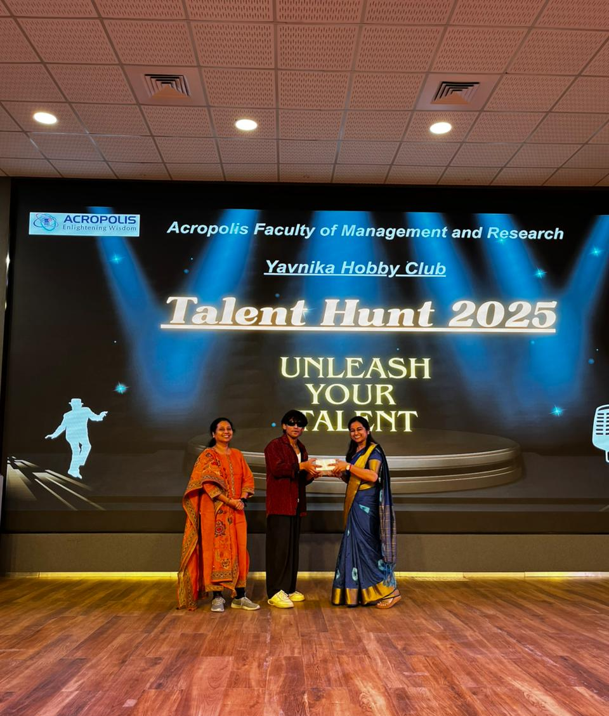 | 